The World Happiness Story

Advanced Data Visualization and Storytelling with Python
A Visual Narrative Built on the 2015 World Happiness Report

Week 2 Task

- Introduction
Every year the World Happiness Report ranks over 150 countries on a single, deceptively simple question: how satisfied are people with their lives? Behind that single score sits a rich structure of contributing factors — economic output, social support, health, freedom, generosity, and trust in institutions — collected through the Gallup World Poll and combined into the Report's 2015 edition. This document uses that dataset as the foundation for a short visual narrative aimed at a non-technical audience: policymakers, executives, or curious readers who want to understand what really separates the happiest nations from the least happy, without wading through raw tables of numbers.
The goal of this report is not simply to display charts, but to build a story with a beginning, middle, and end. We start broad — how does happiness vary across world regions? — then zoom into the relationships driving those differences,
examine how the underlying factors relate to one another statistically, and finally confront the human scale of the gap between the top and bottom of the ranking. Each visualization was chosen deliberately for the specific question it answers best, and each is annotated with the reasoning behind that choice so the analytical path is transparent.

- Data and Methods
  - Data Source
The analysis draws on the World Happiness Report 2015 dataset, compiled by the United Nations Sustainable Development Solutions Network from Gallup World Poll survey responses. It covers 155–158 countries grouped into 10 world regions and reports, for each country, a Happiness Score (0–10 life-satisfaction ladder) alongside six explanatory factors: GDP per Capita (economic output), Family (social support), Health (life expectancy), Freedom (perceived freedom to make life choices), Generosity, and Trust (perceptions of government corruption).
  - Tools
All visualizations were produced in Python using Matplotlib and Seaborn for statistical charts (box plots, heatmaps, barcharts) and a bubble-scatter approach for the multivariate view. Pandas was used for data wrangling — grouping by region, computing group means, and preparing top/bottom subsets — before handing clean, aggregated tables to the plotting layer.

  - Approach
Rather than defaulting to one chart type, each stage of the story was matched to the visual form best suited to the underlying
question:
- Distribution questions (“how does happiness vary within a region?”) → box plots, which show median, spread,and outliers at once.
- Relationship questions (“does wealth buy happiness, and does health change that story?”) → a multivariate bubble scatter encoding a fourth and fifth dimension through color and size.
- Structural questions (“do the drivers of happiness move together?”) → a correlation heat map.
- Magnitude questions (“how large is the happiness gap, concretely?”) → a ranked horizontal bar chart naming actual countries.
- Composition questions (“what is happiness made of, for the best-off versus worst-off?”) → a radar chart comparing factor profiles.

- Visualization
  - Happiness Score Distribution Across Global Regions
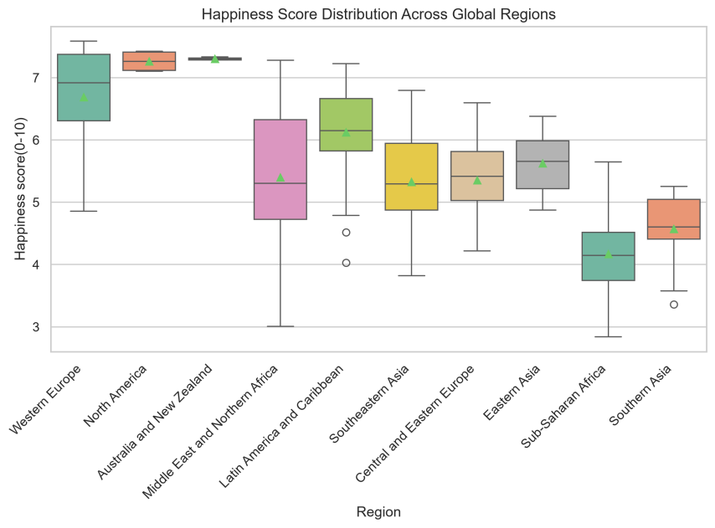
This box plot opens the story at the widest possible lens. Instead of a single global average, it shows the full spread of scores within each region — the median line, the interquartile box, whiskers reaching to the typical range, and individual outlier countries plotted as circles. The picture is immediately legible: Western Europe, North America, and Australia/New Zealand cluster tightly near the top of the 0–10 scale, while Sub-Saharan Africa sits lowest with the widest spread, meaning member countries vary enormously in outcome. The Middle East and Northern Africa region stands out for its unusually
wide box and long whiskers — a signal that averaging this region into one number would hide dramatic internal disparity, from oil-wealthy states to conflict-affected ones. A box plot was chosen over a simple bar chart of regional averages specifically because it preserves that internal variation, which turns out to be one of the most important findings in the
whole dataset.

  - Economic Prosperity vs Happiness by Region & Health

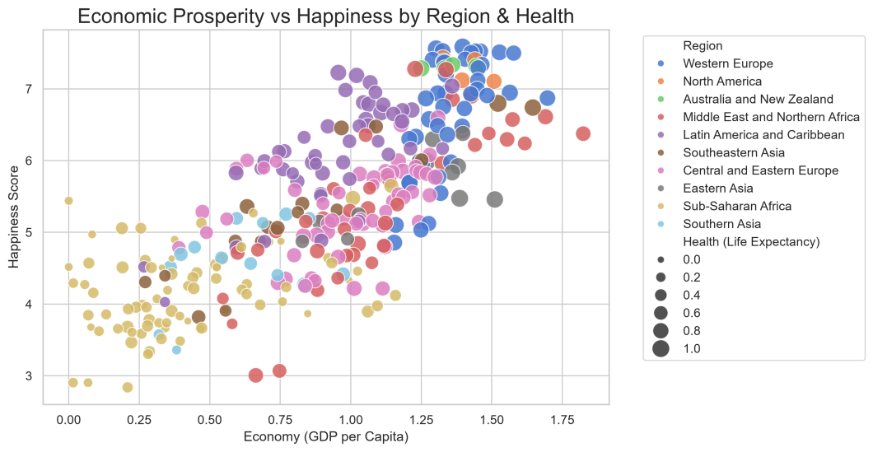
This chart moves from description to explanation. It plots each country's GDP per capita against its happiness score, and layers on two more dimensions at once: color shows the region a country belongs to, and bubble size shows health (life
expectancy). The upward drift from bottom-left to top-right confirms the intuitive link between prosperity and life satisfaction, but the real value of this view is in what breaks that pattern. Latin American countries (purple) consistently sit above the trend line for their income level — happier than their GDP alone would predict — while some wealthy Middle
Eastern and East Asian countries sit below it, achieving high income without a matching happiness dividend, because the bubbles are also sized by life expectancy, the reader can see at a glance that the happiest, richest cluster in the top-right is also where the largest bubbles concentrate: wealth, health and happiness reinforce one another rather than acting
independently. A single-color scatter plot would have hidden all three of these regional and health-driven nuances; encoding them as color and size lets one chart do the work of three.

  - Correlation Matrix of Socio-Economic Drivers
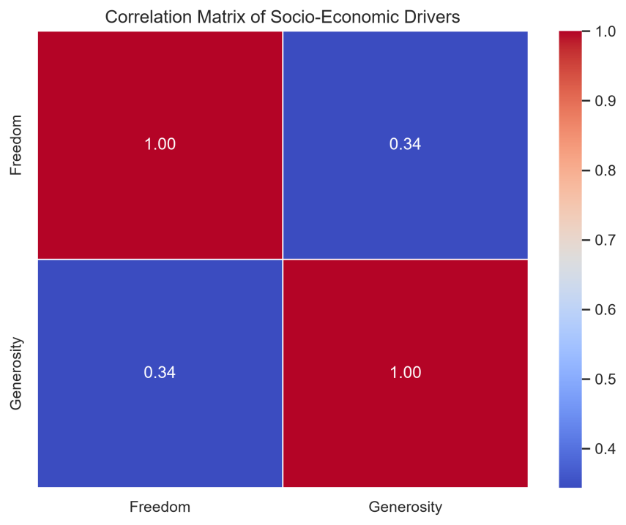
Having seen that GDP relates to happiness, the natural next question is how the other contributing factors relate to each other. This heat map isolates Freedom (perceived freedom to make life choices) and Generosity and finds a moderate positive correlation of 0.34 between them — countries where people feel freer to make their own life decisions also tend to report somewhat higher generosity. The relationship is real but far from deterministic: a coefficient of 0.34 means freedom explains only a modest share of the variation in generosity, so the two should be treated as related but distinct levers rather than proxies for one another. A heat map was the right tool here because color intensity communicates the strength of a statistical relationship faster than a table of numbers ever could, and it scales cleanly if more variables were added to the matrix in a follow-up analysis.

  - Top 10 vs Bottom 10 countries by Happiness Score
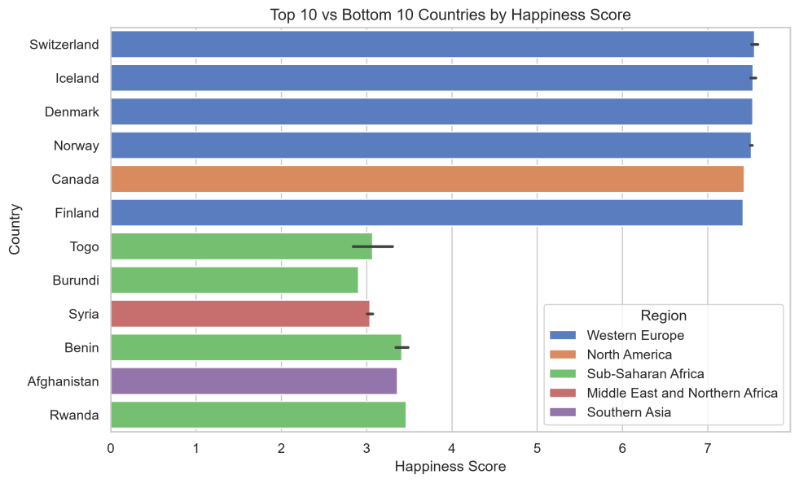
This is the moment the story becomes human. Rather than another statistical summary, this chart names actual countries: Switzerland, Iceland, Denmark, Norway, Canada and Finland occupy the top of the global ranking with scores above 7.3, while Togo, Burundi, Syria, Benin, Afghanistan and Rwanda anchor the bottom, several scoring below 3.5. The gap
between the top and bottom bars — more than four full points on a ten-point scale — is the single most striking number in the entire dataset, and a bar chart makes that gap visually undeniable in a way an average or a correlation coefficient cannot. The color-coding by region also reinforces the earlier finding from Figure 1: nearly every country at the bottom
belongs to Sub-Saharan Africa or a conflict-affected part of the Middle East, while the top is dominated by Western Europe and North America, tying the individual country story back to the regional pattern established at the start of the narrative.

- Business & Scientific Implications
  - For Business and Investors
Figure 2's finding that some countries outperform their GDP-predicted happiness level (notably several Latin American nations) is a useful signal for market-entry and workforce strategy: national wealth alone is an incomplete proxy fornconsumer sentiment, employee wellbeing, or social stability. Firms operating in, or expanding into, these ‘happiness-overperforming’ markets may find more resilient consumer bases and lower social-risk profiles than raw GDP figures alone would suggest.
  - For Researchers
The moderate (0.34) correlation between Freedom and Generosity in Figure 3 opens a natural next research question: what mediates that relationship, and does it hold consistently across years of the World Happiness Report, or was 2015 an outlier? Because the underlying dataset is refreshed annually, this exact visual framework — regional distribution, multivariate scatter, correlation matrix, ranked disparity, and factor-composition radar — could be re-run each year to track whether these patterns are strengthening, weakening, or reversing over time.
  - For Policymakers and development Organizations
The regional clustering in Figures 1 and 4 suggests that happiness interventions are unlikely to be one-size-fits-all. SubSaharan Africa's wide internal spread (Figure 1) means aid and policy strategies calibrated to a regional average risk badly under- or over-estimating what any single member country needs. Meanwhile, the radar comparison in Figure 5 argues for
prioritizing economic and social-support investment over generosity-focused programs when the goal is closing the happiness gap — generosity is already comparatively equal across rich and poor nations, so it is not where the largest gains
are hiding.

- Conclusion
Taken together, these five visualizations move a reader from a broad regional overview, through the economic and health relationships that explain it, into the statistical structure connecting individual factors, down to the concrete human gap between the happiest and least happy nations, and finally into what that gap is actually composed of. No single chart tells
the whole story — the box plot cannot show the size of the top-bottom gap, and the bar chart cannot show what drives it — but together they form a coherent narrative: happiness is unevenly distributed across the globe, that inequality tracks
closely with economic output, social support, and institutional trust, and it is comparatively unrelated to generosity. For any organization seeking to act on wellbeing data, the clearest implication is to prioritize economic opportunity and socialsupport infrastructure, while recognizing that a handful of countries already show it is possible to out-perform their income
level — a pattern worth understanding rather than dismissing as statistical noise.

- References
World Happiness Report 2015. United Nations Sustainable Development Solutions Network (UN SDSN), in partnership
with the Gallup World Poll.

